**Enterprise Resource Planning**

*Of*

**ZAB**

**Training User Manual**

**(SV–12.3.0 | MV–1.0.0)**

**For**

**ASIATIC GROUP**

**Production**

**(Reprocess, Reproduction & Batch Transfer Process)**

**Index**

|  |  |  |
| --- | --- | --- |
| **No.** | **Name** | **Page No.** |
|  | Reprocess | **03** |
|  | Reproduction | **15** |
|  | Batch To Batch Transfer Process | **17** |

If reprocess is needed,

Have to go

**RECIPE SETTING**

# Reprocess

# Setting (for Reprocess)

|  |  |
| --- | --- |
| **Step 1** | Main Menu (Home Icon) **> Production >**  Recipe Setting |
| **Step 2** | Choose the Batch No & click **Show** |
| **Step 3** | Click on **Recipe Setting** |

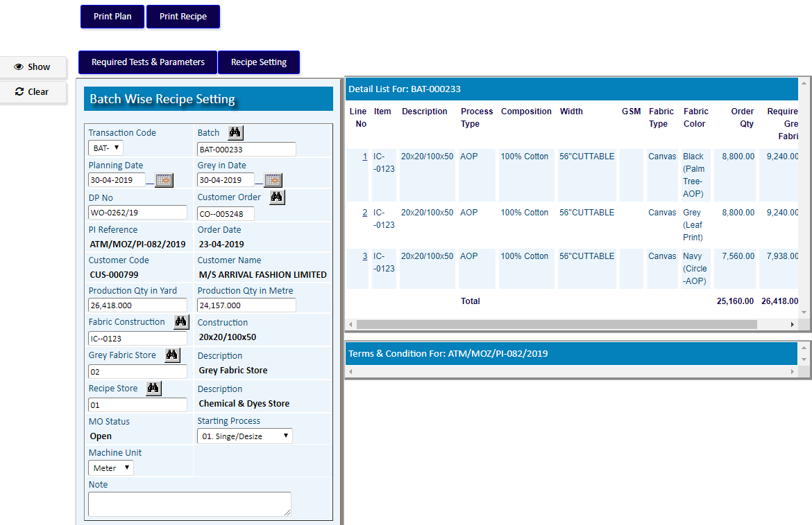

Click on **Recipe Setting**

1. Pick a Process Name (which to be reprocessed) from the side list
2. Set Production Process Type as **Reprocess**.
3. Click **Add**

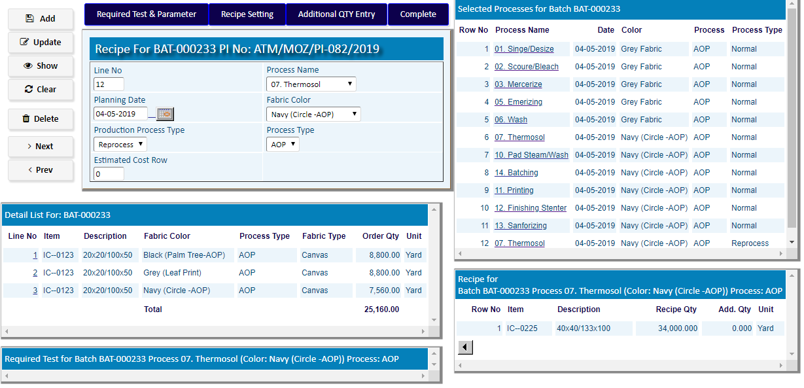

Click on **recipe setting** For the Process (which to be reprocessed)

1. **Add** required Item(s) to reprocess.
2. after Add Items , Click **Complete**

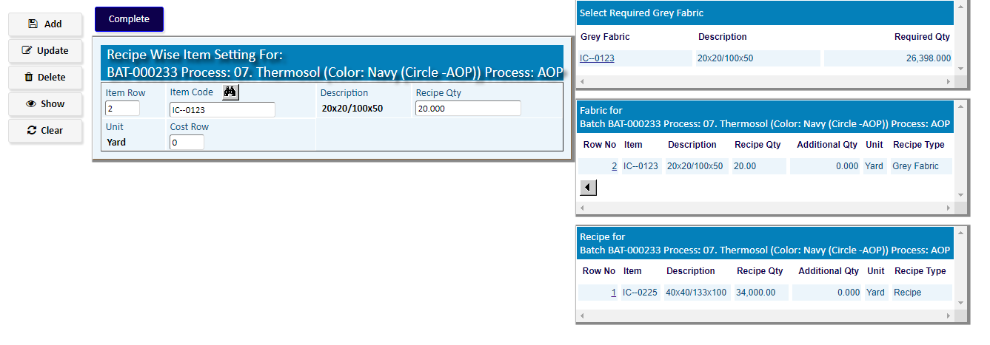

After Adding, Click **Complete**

# Store Requisition (Batch)

|  |  |
| --- | --- |
| **Step 1** | Main Menu (Home Icon) **> Production >**  Store Requisition (Batch) |
| **Step 2** | Choose the Batch Number & Click **Show** |
| **Step 3** | Click **Chemical** for Requisition of Chemical Items |
| **Step 4** | Click **Fabric** for Requisition of Fabric Items |

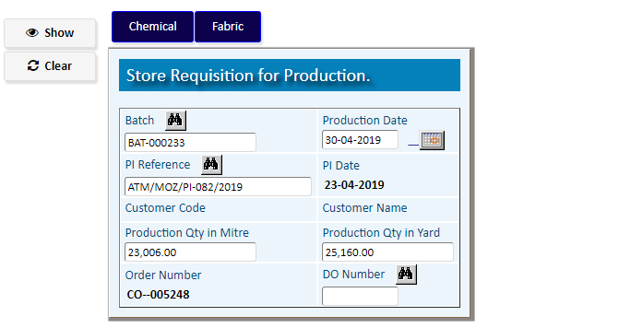

Click **Chemical** for Requisition of Chemical Items

Requisition of Chemical Items

|  |  |
| --- | --- |
| **Step 1** | Choose the **Process Name (for Reprocess)** from list & click **Add** |
| **Step 2** | A new TO of Chemical Requisition will be added |
| **Step 3** | Click **Select Item For Requisition** for Add Chemical Items |

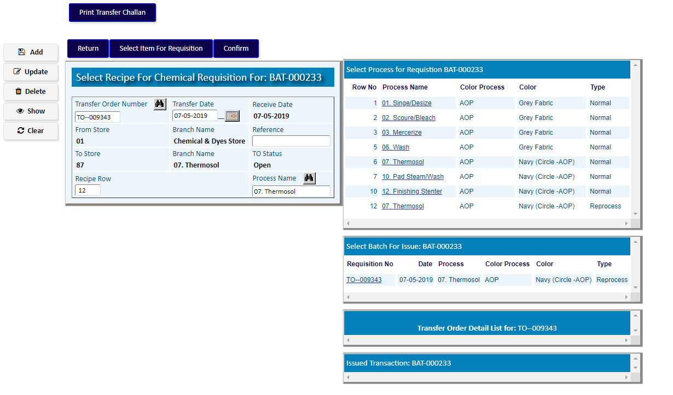

Click **Select Item for Requisition** for Add Chemical Items

**Add** Chemical Items with Item Code, Quantity required & at last, click **Return**

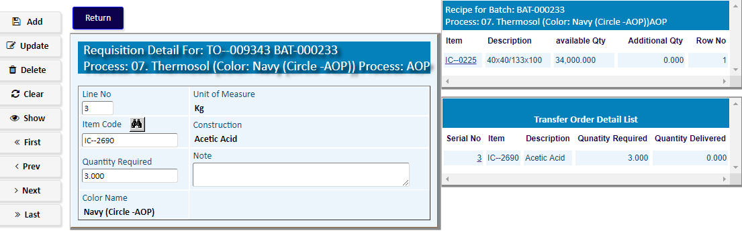

After adding Chemical Items, Click **Confirm** & then click **Return**



# Issue For Production

|  |  |
| --- | --- |
| **Step 1** | Main Menu (Home Icon) **> Production >**  Issue For Production |
| **Step 2** | Choose the Batch Number & Click **Show** |
| **Step 3** | Click **Detail** to issue the materials |

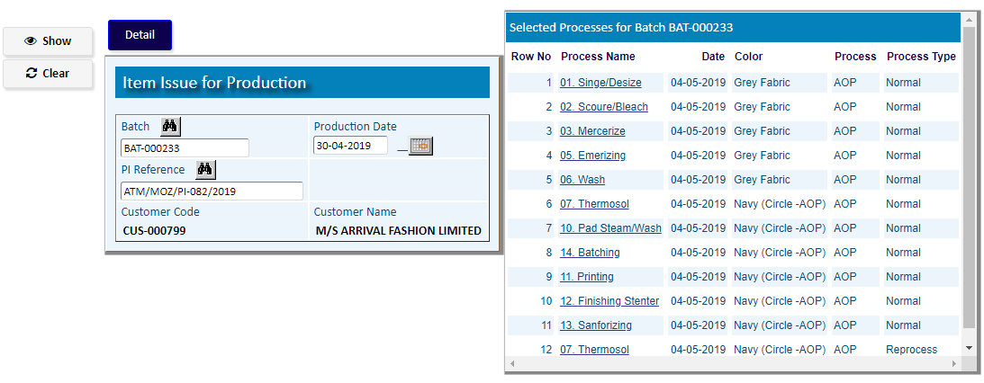

|  |  |
| --- | --- |
| **Step 1** | Select a Process Name (Reprocess Type) from Side list |
| **Step 2** | Click  **Reprocess Material** **Issue** to issue the materials for that reprocess |

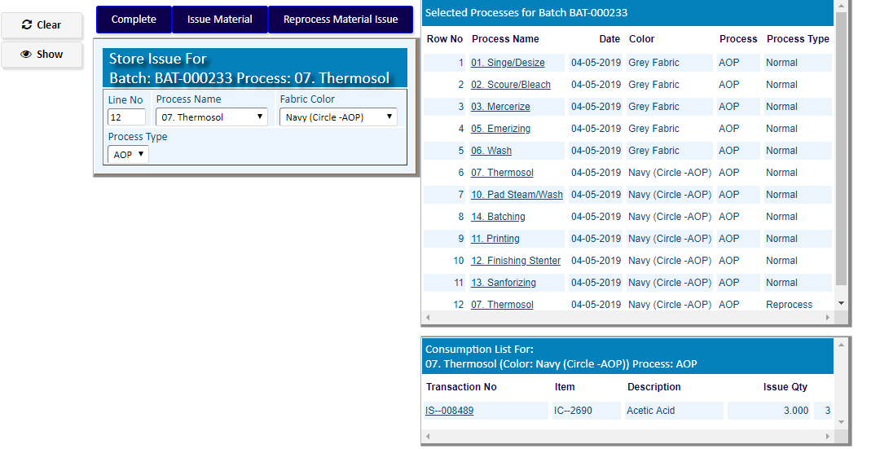

After adding Materials click **Complete**

|  |  |
| --- | --- |
| **Step 1** | Select an Item Code from Side list & click **Add** |
| **Step 2** | Click **Complete** after add |

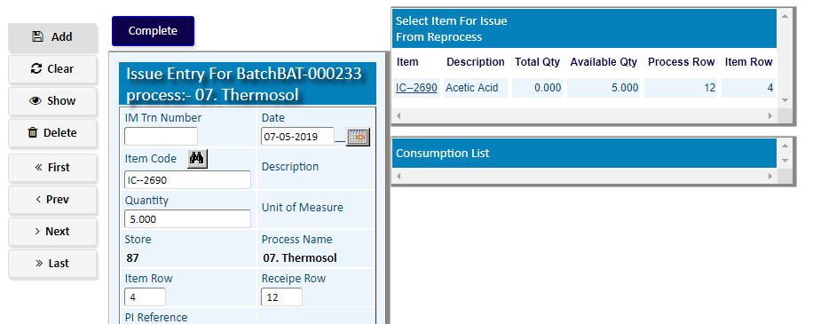

**If Item Stock is not available, you have to go to the Option**

(And to follow the steps as per related manual of this option)

Store Requisition (Bulk)

(Of Production Module)

# Production Process

|  |  |
| --- | --- |
| **Step 1** | Main Menu (Home Icon) **> Production >**  Production Process |
| **Step 2** | Choose **Batch Number ,** & then click **Show** |
| **Step 3** | Click  **Reprocess** _**Start** to Start Process |

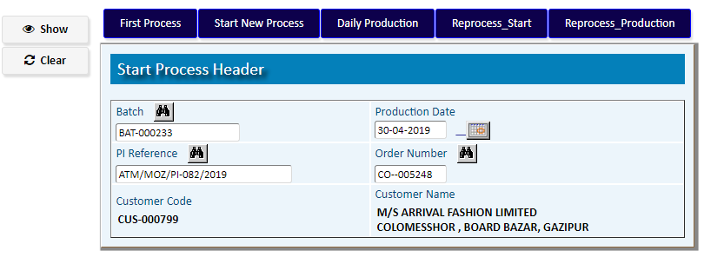

Click **Reprocess** _**Start** to Start Reprocess

|  |  |
| --- | --- |
| **Step 1** | Choose a **From Process** & **Reprocess** Name from side lists |
| **Step 2** | Write process Qty , Unit of Measure & then click **Add** |
| **Step 3** | After Adding, Click **Complete** to go Back |

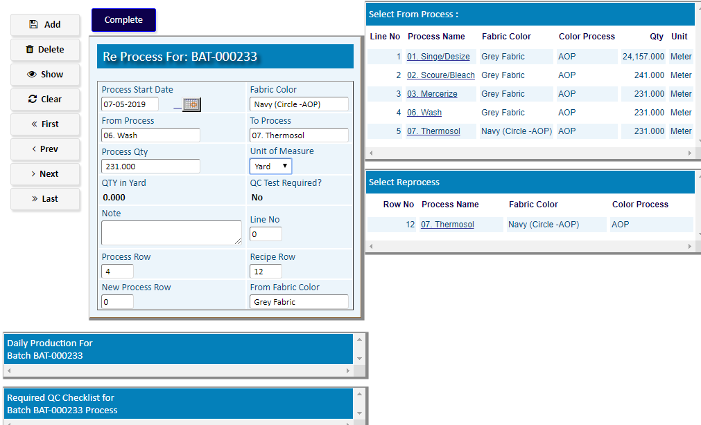

Click **Reprocess** _**Production**

|  |  |
| --- | --- |
| **Step 1** | Choose a **Process Name** from side list |
| **Step 2** | Write Qty, Unit of Measure , Access Qty (If increase Qty), Cause of Additional & then click **Add** |
| **Step 3** | After Adding, Click **Complete** to go Back |

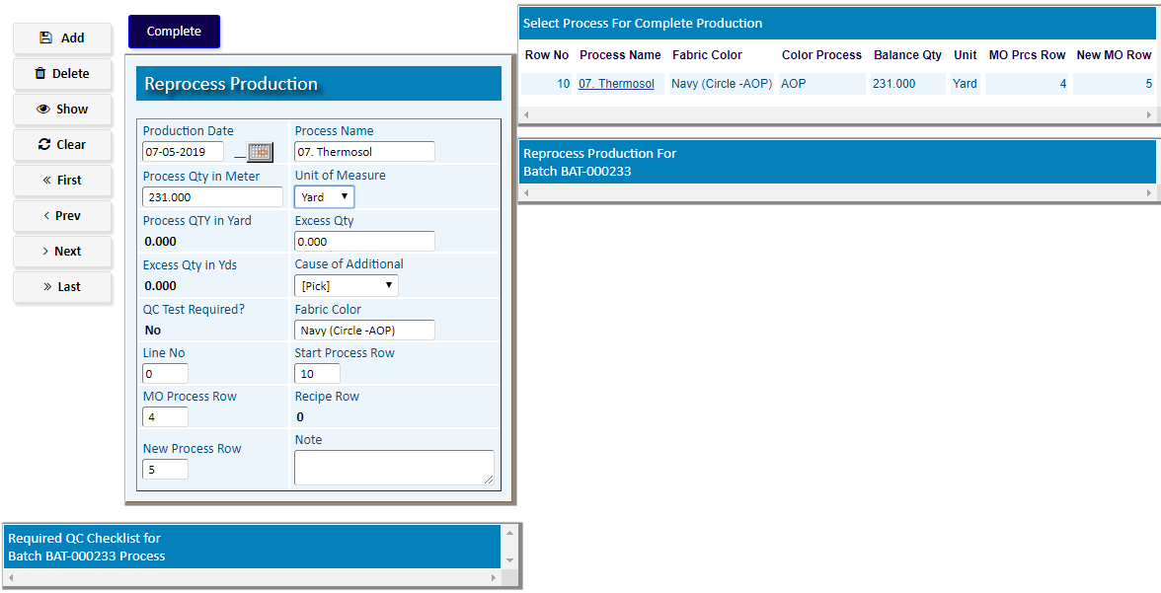

# Reproduction

1. Production Planning Header

|  |  |
| --- | --- |
| **Step 1** | Main Menu (Home Icon) **> Production >**  Production Planning |
| **Step 2** | Write **Customer Order** No., Qty Yard/Meter etc. |
| **Step 3** | Add fabric Construction, Grey Fabric Store, Recipe Store |
| **Step 4** | Assign the Starting Process, set ‘Production Process Type` **Reproduction** & Click **Add** |
| **Step 5** | to Add Products Click **Detail** |

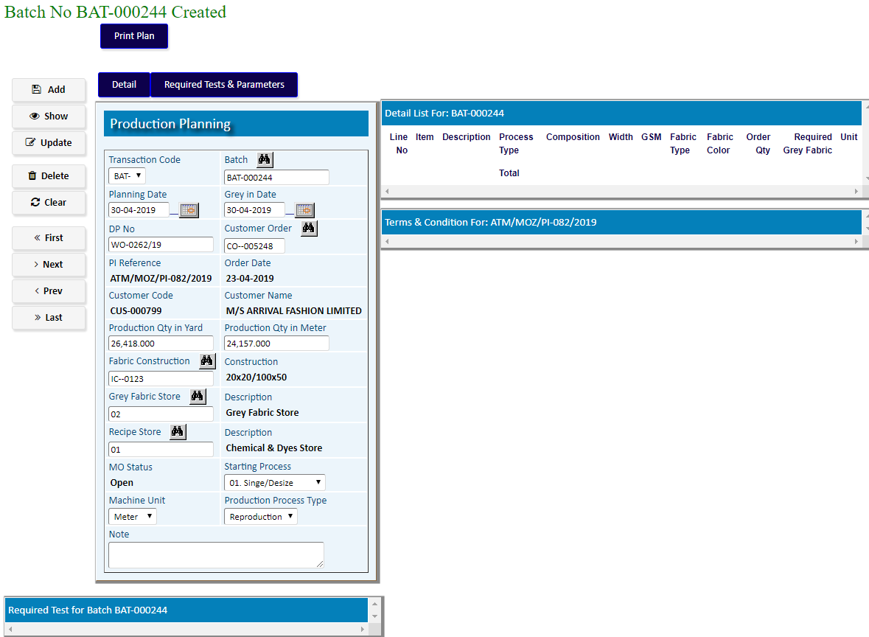(To add Required Test & Parameters click on button **Required Test & Parameters)**

To Add Products Click **Detail**

1. Production Planning Detail
2. Pick a product from the side list of PI Detail
3. Write Selling Unit, Fabric Color.
4. Fill the other Info
5. Click **Add**

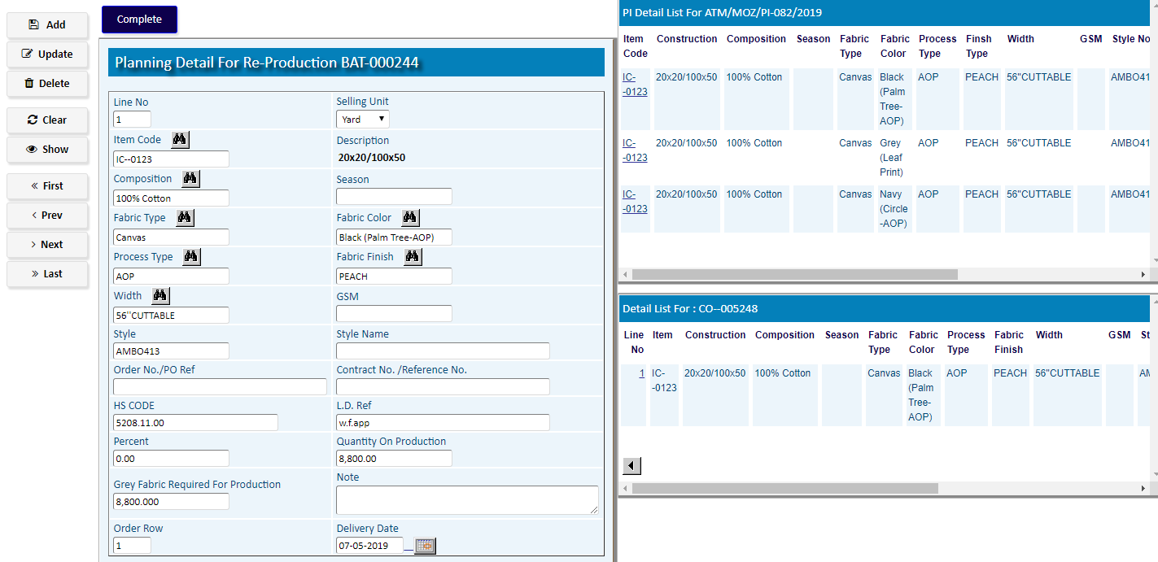

After adding the products, Click **Complete**

**After the Entry of Reproduction Batch,**

**Go to the Following Options (As per related Manual of Production Process)**

**Recipe Setting >> Store Requisition (Batch) >> Issue For Production >> Production Process**

# Batch To Batch Transfer Process

**(If need to transfer the Fabric from A Batch to another batch) [FABRIC CONSTRUCTION of BOTH BATCHES MUST BE SAME]**

|  |  |
| --- | --- |
| **Step 1** | Main Menu (Home Icon) **> Production >**  **BATCH TO BATCH TRANSFER PROCESS** |
| **Step 2** | Choose From Batch, To Batch, & then Click **Add** |

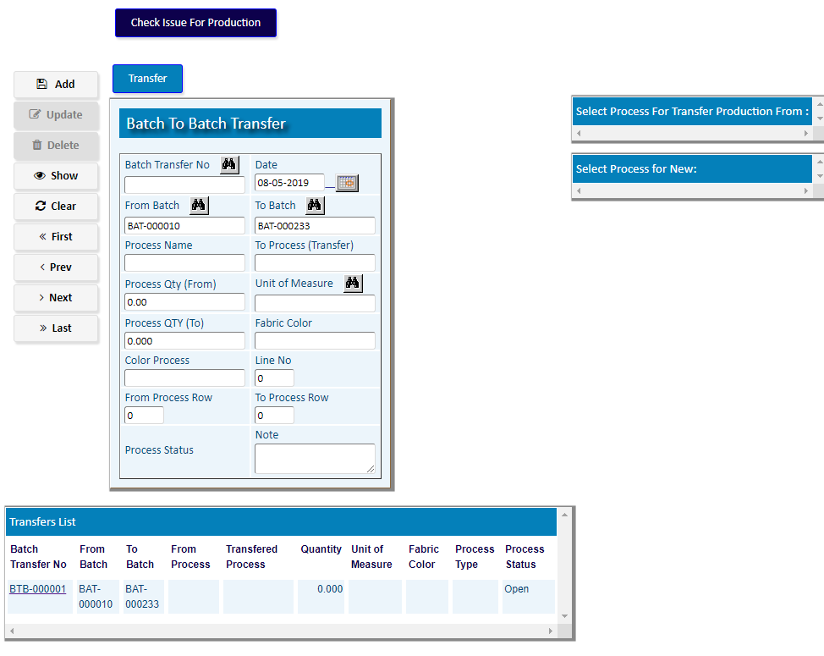

|  |  |
| --- | --- |
| **Step 3** | Choose from Process (from batch list) , to Process (to batch list), from Qty, to qty & click **Update** |
| **Step 4** | Write from Qty, to qty & click **Update** |
| **Step 5** | to check issue Click **Check issue For Production** button |
| **Step 6** | At last (being confirmed) click **Transfer** |
| **Result** | A new Batch transfer will be created |

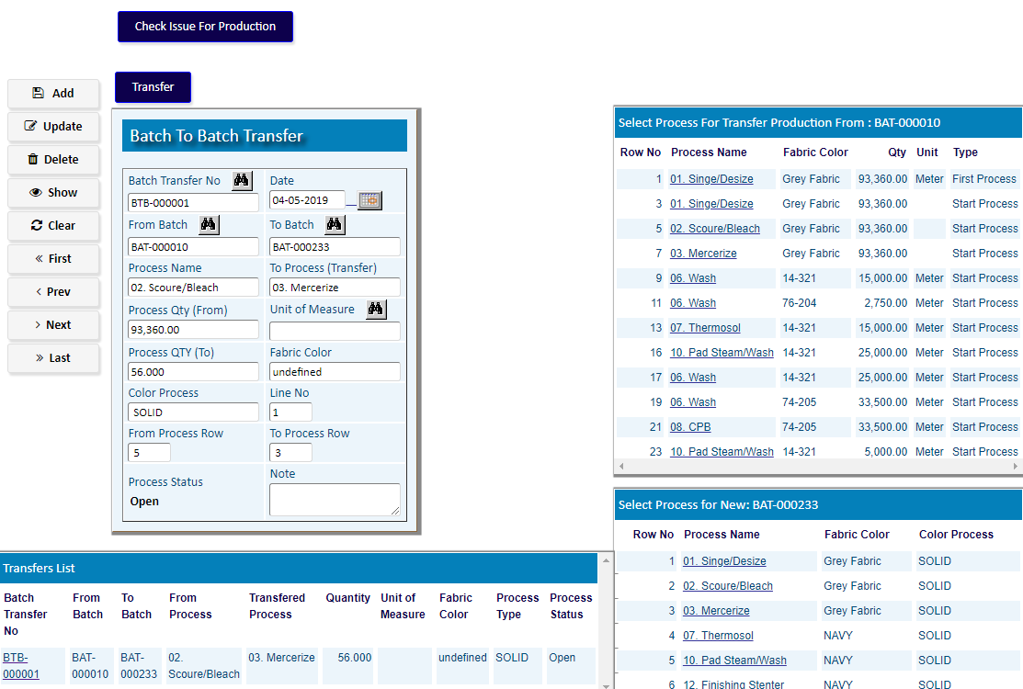

**After Transfer the Batch,**

**Follow the steps (As per related Manual of Production Process)**

**Starting from the To Process (Transfer) of To Batch No.**